Statistical Analysis
Weather data
All data were analyzed using R version 4.1.1. Weather data were obtained from the Florida Automated Weather Network (FAWN) station Alachua 260 (29.801729, -82.410249; Euclidean distance from study site: 19.09 km). Once acquired, weather data were subset to our sampling day (October 21, 2020 – XX) and averaged over our sampling times (9:00 am – 12:00 pm, owing to hourly recording of weather data). We tested the effects of soil temperature, temperature at 60 cm, 2m, and 10m, dewpoint temperature, humidity, rainfall, wind direction and speed, and solar radiation for significant effects on our response variables. Variables that were significantly correlated with our response variables were included in a principal component analysis (PCA) to reduce the suite of related weather variables into two covariates.

Tests for significance
We first analyzed the effect of pollen substitutes on the proportion of bees with dye in their guts. Each bee gut was visually inspected by two researchers blind to each other’s response and between these two visualizers, only 3.73% (257 lines of data) disagreed with each other. We removed these disagreeing samples from the analysis. To compare the overall effect of treatments, we used a binomially distributed bias-reduced general linear model in the brglm2 package (Kosmidis and Firth, 2020), owing to complete separation between the consumptive and negative control (0 bees with dye in their gut) and the other treatments. The model used in this comparison was: [dye visual ~ treatment + PC1 + PC2 + colony]. We then subset the data to analyze the effect of sample day on dye visualization using a binomially distributed GLMM with the package afex (Singmann et al. 2019) which is built upon the lme4 package (Bates et al. 2015) in only the AP23 treatment. The model for this analysis was: [dye visual ~ sample day + PC1 + PC2 + colony (random effect)]. We then analyzed the effect of treatment and sample day on the number of marked bees counted on pollen patties. To test the effect of treatment, we used a bias-reduced generalized linear model from the brglm2 package in r (Kosmidis and Firth, 2020). Here, only the consumptive control had 0 observations. Next, we tested the effect of the interaction between sampling day and the non-zero treatments using a Poisson- distributed GLMM and the model: [number of marked bees ~ cumulative bees removed + treatment * sampling day + PC1 + PC2 + date sampled (random) + area of pollen remaining (random) + colony number (random)]. As above, we then separated the AP23 treatment to analyze the effect of sampling day on the number of marked bees observed again using a Poisson distributed GLMM with the model: [number of counted bees ~ cumulative bees removed + temperature at 2 m + sampling day + date (random effect) + area of pollen remaining (random effect)]. Roughly 20 bees were removed for the dye visualization response variable, so we added the number of bees removed per day to create a “cumulative number of bees removed” variable and we used this as a covariate.

Results
FAWN weather data
Weather data were highly correlated with both response variables measured in this study. On the number of marked bees counted on pollen patties, the dewpoint temperature, humidity, rainfall, wind direction, solar radiation, and temperatures at 60 cm, 2m, and 10m were significant predictors (Table 1). The PCA for these variables reduced the variability to principal components, the first explained 63.47% of the variability and the second explained 15.34%. Bees that were shown to have dye in their guts were significantly correlated with soil and dewpoint temperatures, humidity, rainfall, wind speed, and temperatures at 60 cm, 2m, and 10m (Table 1). PC1 for this response variable explained 64.6% of the variability, and PC2 explained 17.83%.

Dye visualization
No dye was recovered from either the consumptive or negative controls at all during the experiment, and there was a 96.13% recovery for the positive control. In the AP23 treatment, dye was recovered from 45.8% of bees over the course of the experiment. There was a significant difference between these treatments (χ²_{3, 2705} = 4661.9, p < 0.001). After the removal of controls, there was a significant effect of the sampling day on the AP23 treatment (χ²_{27, 2705} = 98.28, p < 0.001, Figure 1).

Marked bees counted on pollen supplements and controls
No bees were observed interacting with the treatment in the consumptive control group. In the negative control, 1.27 ± 0.18 (se) bees were observed on average across the experiment. There were an average of 1.19 ± 0.15 bees on the positive control across the experiment, and an average of 1.6 ± 0.15 bees on the dyed AP23 treatment. There was no significant effect of treatment across the 3 treatments with bees observed (χ²_{2,318} = 1.29, p = 0.525), but there was a significant interaction between treatment and sampling day (χ²_{54,318} = 84.31, p = 0.005). In the dyed AP23 treatment, there was a significant effect of the sampling day (χ²_{27,162} = 100.59, p < 0.001, Figure 2).

Table 1: Significant of weather data on both response variables.
Weather Variable | Bee Counts |  | Dye Visuals
 | Chi-sq | p-value | Chi-sq | p-value
Soil Temperature | 2.95 | 0.086 | 41.46 | <0.001
Temperature 60 cm | 18.67 | <0.001 | 12.88 | <0.001
Temperature 2 m | 19.4 | <0.001 | 10.3 | 0.001
Temperature 10 m | 19.84 | <0.001 | 9.92 | 0.002
Dew point temp | 22.79 | <0.001 | 13.82 | <0.001
Humidity | 19.2 | <0.001 | 12.27 | <0.001
Rainfall | 29.47 | <0.001 | 4.08 | 0.043
Wind speed | 1.66 | 0.198 | 34.76 | <0.001
Wind direction | 4.49 | 0.034 | 0.51 | 0.473
Solar radiation | 7.88 | 0.005 | 2.24 | 0.134

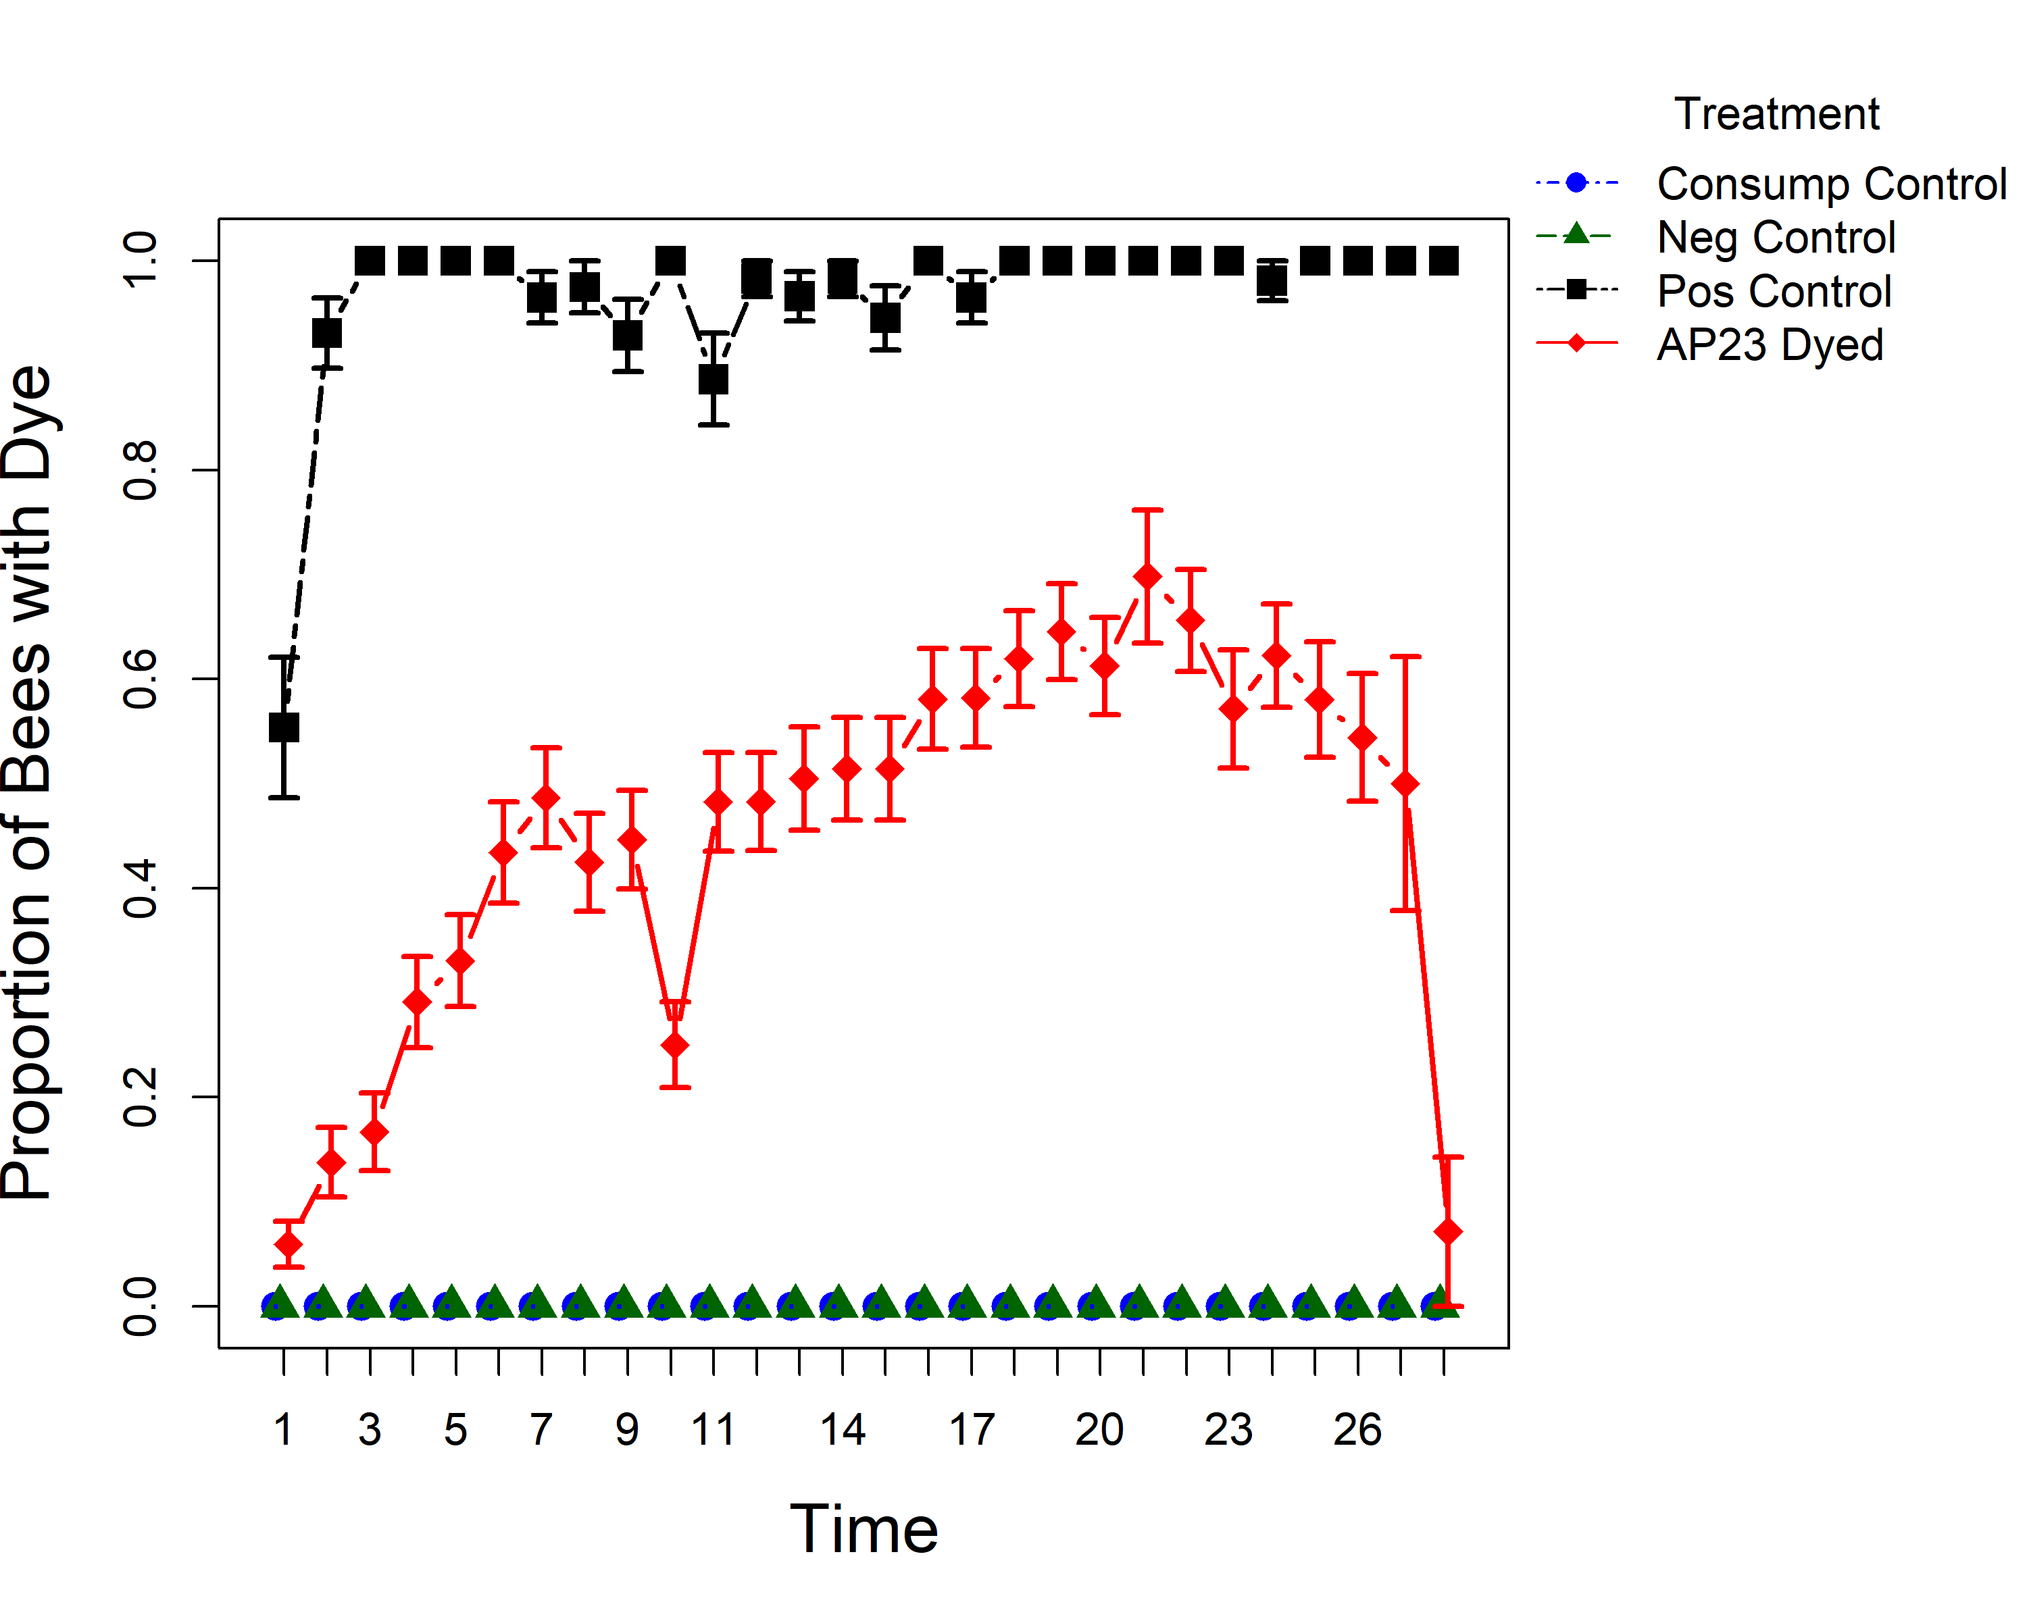
Figure 1: Bees observed with dye in their guts for each sampling day. Consumptive control (blue circles) and negative control (green triangles) had 0 observations across the experiment. Error bars represent standard error. Time on the x axis represents number of days.

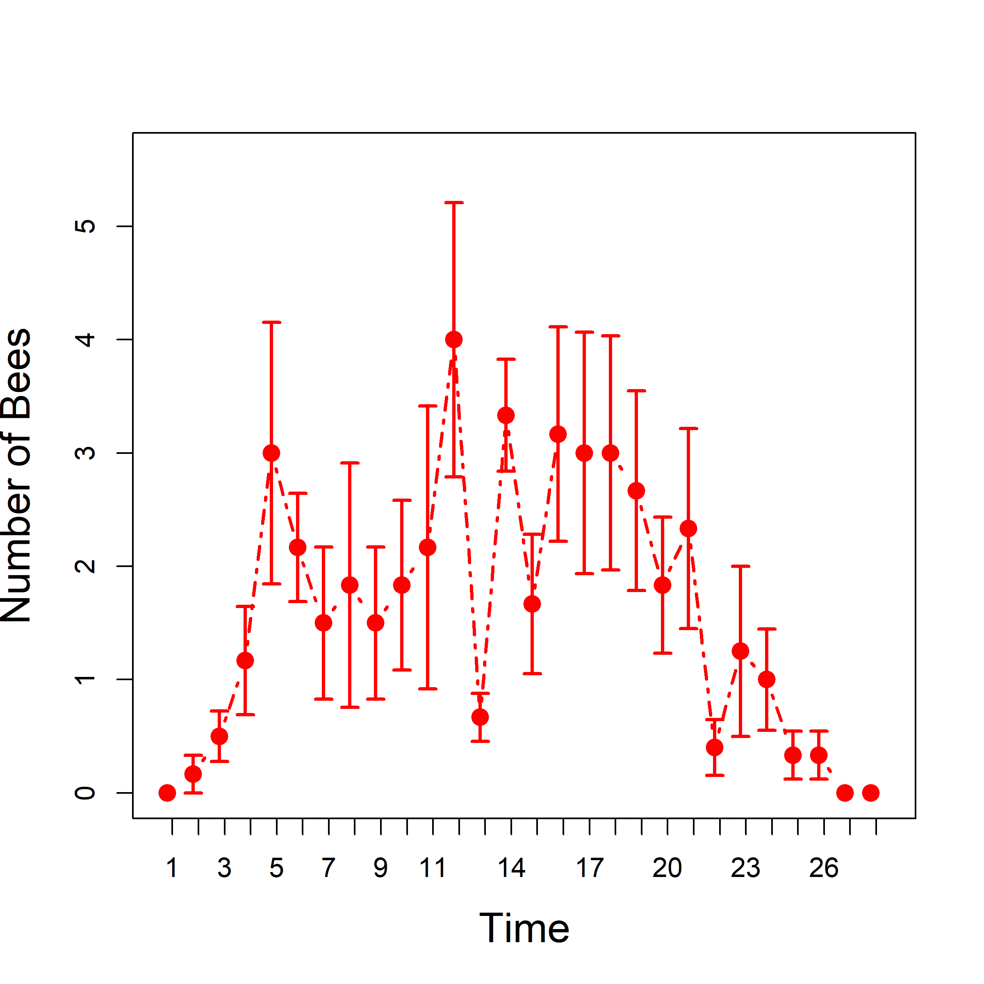
Figure 2: Number of bees observed interacting with the dyed AP23 treatment. Error bars represent standard error. Time on x-axis represents day of observation.

Citations
Bates, D., M. Maechler, B. Bolker, and S. Walker. 2015. Fitting linear mixed-effects models using lme4. J. Stat. Softw. 67: 1–48.
Kosmidis I, Firth D (2020). “Jeffreys-prior penalty, finiteness and shrinkage in binomial-response generalized linear models.” Biometirka. https://doi.org/10.1093/biomet/asaa052.
Singmann, H., B. Bolker, J. Westfall, F. Aust, and M. S. Ben-Shachar. 2019. afex: analysis of factorial experiments. R Package.

